He Kissed Me SPA STRUMMERS DJ 28/04/17 V2
by Phil Spector, Ellie Greenwich & Jeff Barry
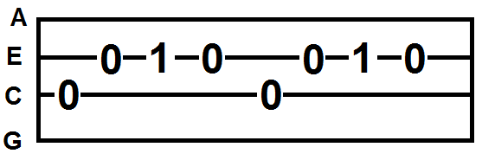
1-2-3-4 ALL PICK ( OR C E F E X 2 )

Well, he [C]walked up to me

and he [G]asked me if I wanted to [C]dance.
C
He [C]looked kinda nice
and [G]so I said I might take a [C]chance.
[F]When he danced he [C]held me tight
G
[F]And when he walked me [C]home that night
[C]All the stars were [G]shining bright
And then he [C]kissed me.
F
[C]Each time I saw him
I [G]couldn't wait to see him [C]again.
I [C]wanted to let him [G]know
that he was more than a [C]friend.
[F]I didn't know just [C]what to do
[F]so I whispered [C]I love you
[C]And he said that he [G]loved me too
And then he [C] kissed me.
Dminor
[F]He kissed me in a way
that I've [Dm]never been kissed be[F]fore,
He [D]kissed me in a way
that I [G]wanna be kissed forever [G7]more.
I [C]knew that he was mine
so I [G]gave him all the love that I [C]had
And [C]one day he took me [G]home
to meet his mum and his [C]dad.
[F]Then he asked me to [C]be his bride
[F]And always be right [C]by his side.
[C]I felt so happy I [G]almost cried
And then he [C]kissed me.

[F]Then he asked me to [C]be his bride
[F]And always be right [C]by his side.
[C]I felt so happy I [G]almost cried
And then he [C]kissed me. [G]
And then he [C]kissed me. [G]
/ /
And then he [C]kissed me. STOP

